**Project Report Format**

1. **INTRODUCTION** 
   1. Project Overview

Pollen profiling is a critical process in the fields of botany, ecology, and allergy diagnostics. Traditionally, classifying pollen grains has been a manual, time-consuming task prone to human error. This project presents a Flask-based web application integrated with a Convolutional Neural Network (CNN) model capable of accurately classifying pollen grain images. The system provides an intuitive interface for uploading images and instantly receiving classification results powered by deep learning.

* 1. Purpose

The main purpose of this project is to automate the classification of pollen grains using machine learning. By combining a trained CNN with a user-friendly web interface, the application aims to:

Reduce manual workload and subjectivity in identification.

Provide quick and reliable predictions for researchers and students.

Demonstrate how deep learning can be effectively integrated into real-world tools.

1. **IDEATION PHASE**
   1. Problem Statement
   2. Empathy Map Canvas
   3. Brainstorming
2. **REQUIREMENT ANALYSIS**
   1. Customer Journey map
   2. Solution Requirement
   3. Data Flow Diagram
   4. Technology Stack
3. **PROJECT DESIGN** 
   1. Problem Solution Fit
   2. Proposed Solution
   3. Solution Architecture
4. **PROJECT PLANNING & SCHEDULING** 
   1. Project Planning
5. **FUNCTIONAL AND PERFORMANCE TESTING** 
   1. Performance Testing
6. **RESULTS** 
   1. Output Screenshots

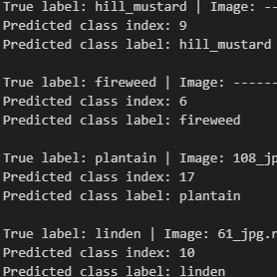

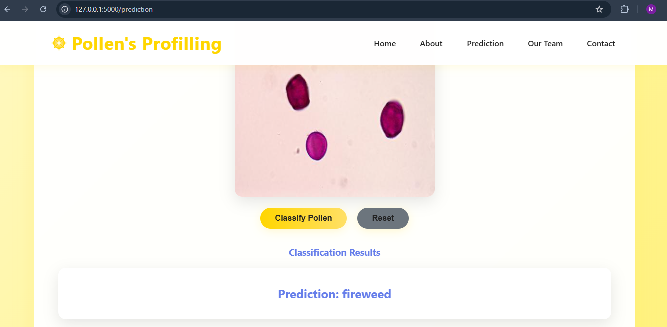

1. **ADVANTAGES & DISADVANTAGES**

✔️ **Advantages:**

* Saves time
* Accurate predictions
* Easy to use

✔️ **Disadvantages:**

* Depends on dataset quality
* Needs internet if deployed online
* Misclassification if image quality is poor

1. **CONCLUSION**

Pollen’s Profiling is a deep learning-based project that automatically identifies and classifies pollen grains from images. It replaces manual identification, which is slow and requires expert knowledge. The system uses a CNN model to predict the type of pollen quickly and accurately. It also includes a simple web interface where users can upload images and get instant results. This solution saves time, improves accuracy, and helps researchers, students, and farmers in their work.

1. **FUTURE SCOPE**

• Add more pollen types

• Convert to a mobile app

• Use advanced AI models

• Deploy globally with cloud hosting

1. **11. APPENDIX**

Source Code(if any)

Dataset Link https://www.kaggle.com/datasets/nataliakhanzhina/pollen20ldet?utm_source=chatgpt.com

GitHub & Project Demo Link

https://github.com/mvnsuseelkumar/Pollen-s-Profiling-Automated-Classification-of-Pollen-Grains.git